**Design Thinking Project Workbook**

**Don't find customers for your product but find products for your customers**

**1. Team**

**Team Name: CODE BUILDER**

**Team Members:**

1. Manasa, Creating The Code Of Project, 2320030205
2. Rishika, interaction with clients, 2320030471
3. Gayathri, research of project in social platforms, 2320030382

**2. Problem/Opportunity Domain**

**Domain of Interest: AI-Assisted Code Generation**

**Description of the Domain:**

Code generation is a critical aspect of software development, enabling faster and more efficient coding processes. Traditional development requires manual coding, which can be time-consuming and prone to errors. AI-powered code generation leverages machine learning models like Gemini AI to analyze problem statements, input-output specifications, and expected results, automating the process of writing accurate and optimized code. This technology enhances productivity, reduces development costs, and supports multiple programming languages and frameworks.

**Why did you choose this domain?:**

* Personal interest in AI-driven automation and its impact on software development?
* High industry demand for intelligent coding assistants that improve efficiency and accuracy?

**3. Problem/Opportunity Statement**

**Problem Statement:**

Current weather forecasting systems often fail to provide hyper-local, real-time predictions with high accuracy, leading to inefficiencies and economic losses.

**Problem Description:**

Developers often struggle with writing code from scratch, debugging errors, and ensuring efficiency. Traditional development methods lack automation, making it difficult to quickly generate code that meets problem-specific constraints and expected outputs. AI-assisted solutions can streamline this process by analyzing problem statements and generating optimized code automatically.

**Context (When does the problem occur):**

* When developers need quick, accurate code solutions.
* During competitive programming, software prototyping, or automation tasks.

**Alternatives (What does the customer do to fix the problem):**

* Search for solutions online (Stack Overflow, GitHub, forums).
* Write and debug code manually.

**Customers (Who has the problem most often):**

Software developers, students, competitive programmers, businesses needing automation, and non-programmers looking for code solutions.

**Emotional Impact (How does the customer feel):**

* Frustrated by time-consuming coding and debugging.
* Overwhelmed when learning new programming languages or solving complex problems.

**Quantifiable Impact (What is the measurable impact):**

* Time savings due to automated code generation.
* Faster software development cycles and reduced debugging efforts.
* Increased accessibility for non-experts to generate functional code.

**Alternative Shortcomings (What are the disadvantages of the alternatives):**

* Manually searching for solutions can be inefficient and unreliable.
* Writing code from scratch increases development time and the likelihood of errors.

**Any Video or Images to showcase the problem:**

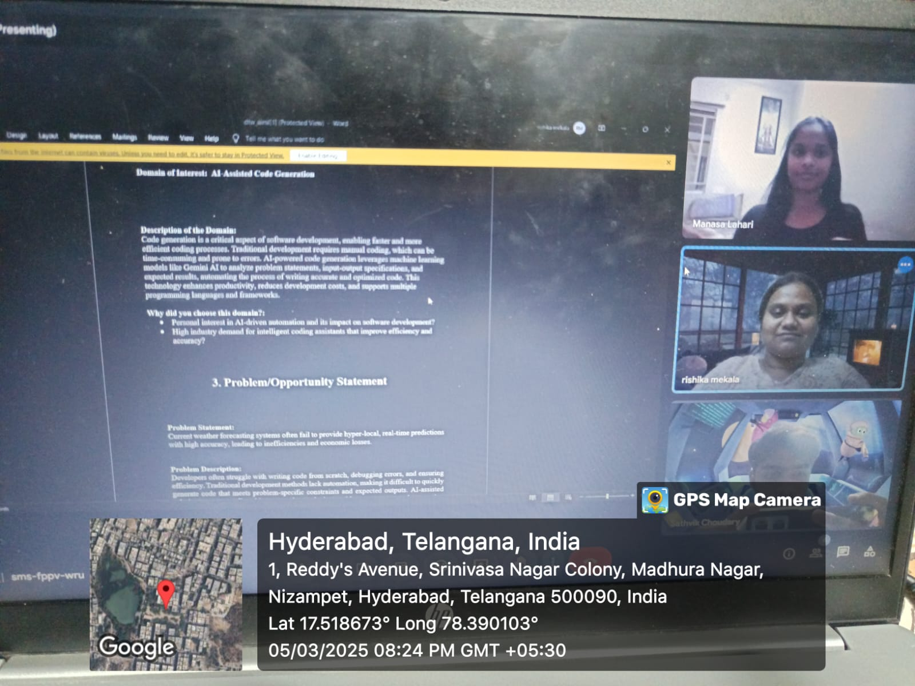

**3. Addressing SDGs**

**Relevant Sustainable Development Goals (SDGs):**

* SDG 4: Quality Education
* SDG 9: Industry, Innovation, and Infrastructure

**How does your problem/opportunity address these SDGs?:**

* SDG 4 (Quality Education): Code Builder democratizes access to programming by enabling students and beginners to learn and generate code efficiently, reducing the barrier to entry in software development.
* SDG 9 (Industry, Innovation, and Infrastructure): AI-driven code generation fosters innovation by streamlining software development, improving productivity, and accelerating technological advancements in various industries.

**4. Stakeholders**

Answer these below questions to understand the stakeholder related to your project

1. **Who are the key stakeholders involved in or affected by this project?**

Software developers, students, educators, tech companies, startups, and AI researchers.

1. **What roles do the stakeholders play in the success of the innovation?**

Developers and students use the platform, companies integrate it, startups benefit from automation, and researchers enhance AI capabilities.

1. **What are the main interests and concerns of each stakeholder?**

Industries Developers need accurate code, companies seek efficiency, startups want fast development, and researchers focus on AI advancements.

1. **How much influence does each stakeholder have on the outcome of the project?**

Developers, companies, and researchers have high influence, while students and educators have moderate influence.

1. **What is the level of engagement or support expected from each stakeholder?**

High High engagement from developers, students, and researchers, with moderate involvement from companies and startups.

1. **How will you communicate and collaborate with stakeholders throughout the project?**

Through online forums, GitHub, social media, open-source contributions, feedback loops, and research partnerships.

**5. Power Interest Matrix of Stakeholders**

**Power Interest Matrix:**

**High Power, High Interest: Meteorological agencies, AI researchers High Power, Low Interest: Government authorities Low Power, High Interest: Farmers, logistics compnies, consumers Low Power, Low Interest: General public**

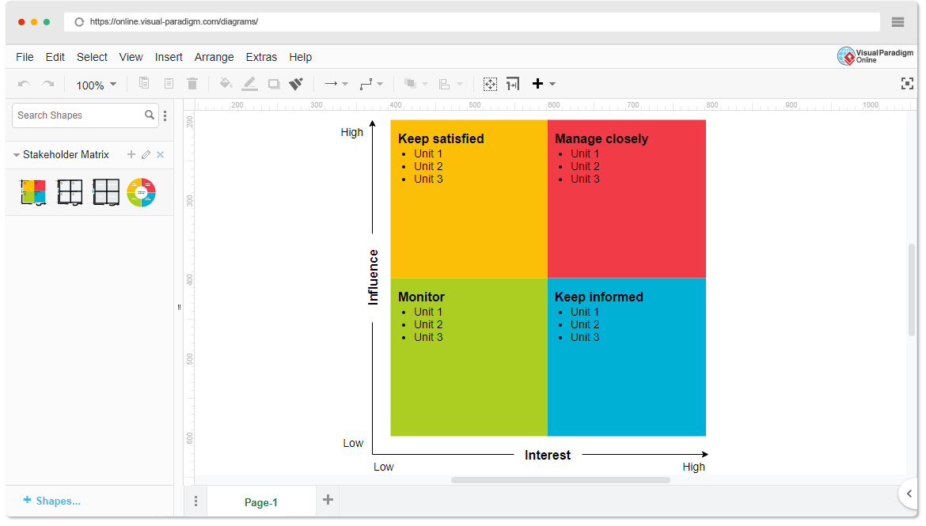

* **High Power, High Interest:** Tech companies, AI researchers
* **High Power, Low Interest:** Regulatory bodies, educational institutions
* **Low Power, High Interest:** Developers, students, startups
* **Low Power, Low Interest:** General public

**6.Empathetic Interviews**

**Conduct Skilled interview with at least 30 citizens/Users by asking open ended questions (What, why/How etc) and list the insights as per the format below**

|  |  |  |
| --- | --- | --- |
| **I need to know**  **(thoughts, feelings, actions)** | **Questions I will ask**  **(open questions)** | **Insights I hope to gain** |
| Thoughts | What are your key expectations from an AI-powered code generation tool? | Understand what users seek in automated coding solutions. |
| How accurate and reliable is the AI model? | How accurate and reliable should AI-generated code be? | Identify key success indicators for AI-driven code generation. |
| Will this project provide a competitive edge? | Will this tool provide a competitive advantage in software development? | Learn if AI-generated code can improve efficiency and productivity. |
| Feelings | How confident are you in AI-generated code? | Assess trust levels and skepticism among developers. |
| Enthusiastic but cautious about AI's potential | What concerns do you have about AI automating coding tasks? | Identify fears related to job displacement or code reliability. |
| Motivated to ensure project success | How would an AI coding assistant impact your workflow? | Understand how users perceive AI in their daily coding tasks. |
| actions | What programming languages and frameworks should the tool support? | Gather insights on preferred languages and tools. |
| Actively participate in decision-making | How would you like to interact with the AI tool? | Identify user preferences for UI/UX and integration. |
| Provide funding, resources, and strategic direction | What concerns do you have regarding data security and privacy? | Address ethical considerations and trust factors. |

**SKILLED INTERVIEW REPORT**

**(Examples are given. Erase them and fill with your user information.)**

|  |  |  |
| --- | --- | --- |
| **User/Interviewee** | **Questions Asked** | **Insights gained (NOT THEIR ANSWERS)** |
| Sathvik, Computer Science Student | What are your key expectations from an AI-powered code generator? | Students want AI-generated code to be explainable and beginner-friendly. |
| Manaswi, Software Developer | How do you currently handle complex coding tasks? | Developers spend a lot of time debugging and optimizing code manually. |
| Karthik, AI Researcher | How confident are you in AI-generated code? | AI researchers believe AI can assist but should not replace human oversight. |
| Rohit, Startup Founder | What features would make this tool indispensable for your work? | Startups seek AI-generated code that integrates seamlessly with their existing tech stacks. |
| Deepthi, Educator | |  | | --- | |  |  |  | | --- | | How would an AI assistant impact your learning process? | | **Educators want AI tools to enhance, not replace, traditional programming education.** |